**EXPERIMENT 3**

**Aim :**

Develop a Phone Book Application for Mobile Phone using Android Studio.

**Theory :**

The main objective of this application is to avoid confusion while searching for the names in the contact list. It is easy to save a contact but what if the number is different and the name of two persons is the same. The solution is to save the numbers with the same name but in two different fields. This application contains different fields, where contacts of people belonging to the particular field can be saved there.

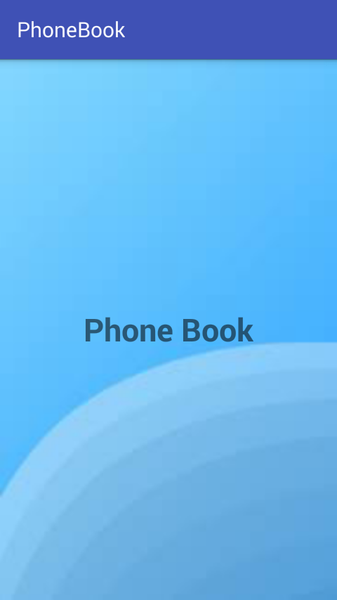

**Abstract :**

Creating a contact in our phonebook seems to be easy, but it becomes little confusing when we search for names in the contact list as two or more people may have the same name but different numbers. To avoid this confusion, we have added few fields to currently existing phonebook which makes it a smart-phonebook. Fields like friend, family, work, relative as per the requirement are included in this application. This application will be very helpful for the people having a big list of contacts.

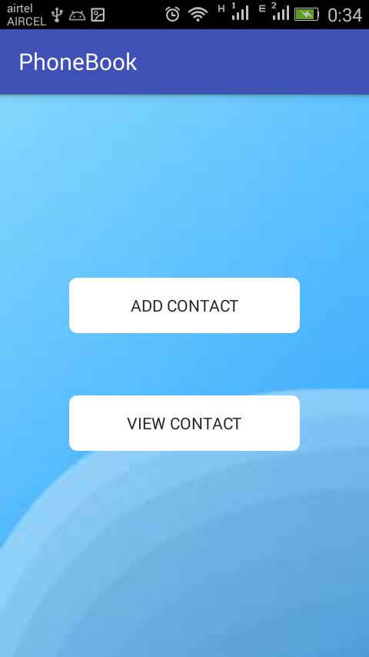

**Requirements :**

***Software:***

* Operating System - Windows 10 Home
* Technology - Android
* Backend - Java SE
* Frontend - XML (as UI)
* Tools - Android Studio / Android SDK

***Hardware:***

* Processor - Intel(R) Core(TM) i5
* RAM - 8.00 GB
* Hard disk - 3.00 GB

**Scope :**

This is an offline application which manages to save one’s, part of personal information like contact number, address and email id if applicable. It can be accessed by the phone user only. Every person has many contacts in their list but may or may not classify contacts into groups.

**Proposed System :**

* This offline phonebook can save several numbers of contacts belonging to different fields.
* Fields can be named as per the user’s wish, suppose one field belongs to the business, then in business there may be many sub-fields.
* The prime advantage is that many people can be classified according to their fields or sub-fields to avoid confusion while retrieving the contact.
* A call to any person can be easily done without searching the whole list of contacts, we can directly shift to the field and sub-field of that contact and perform this task.

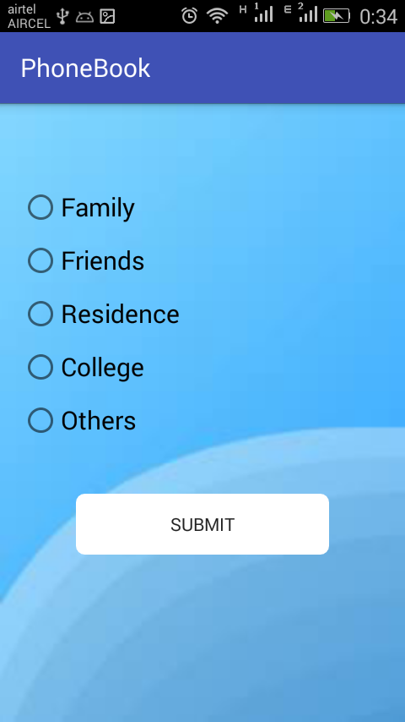 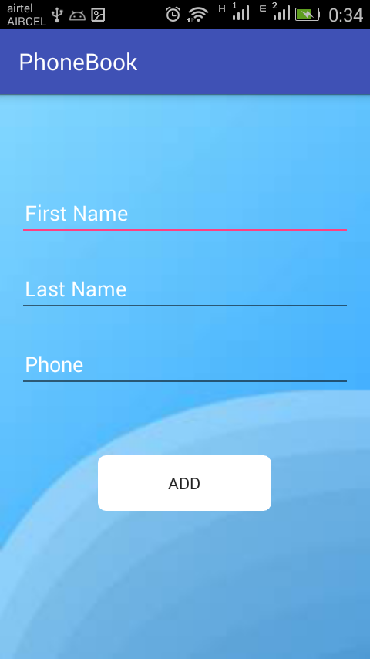

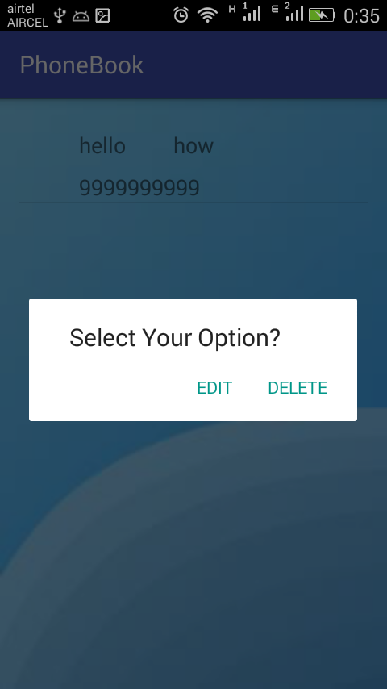 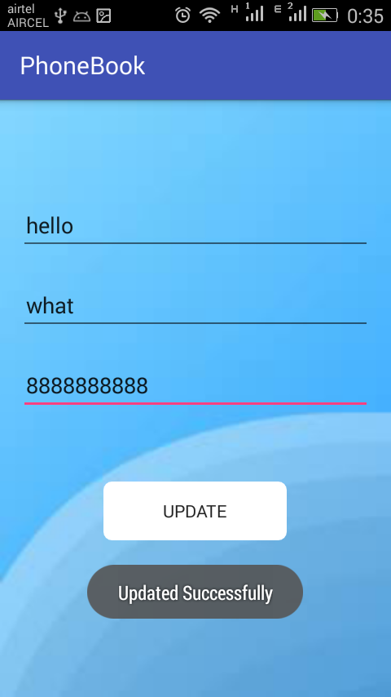

**Existing System :**

* As for now, we have a normal phone book on every phone. This is a phonebook application that can be used only in smartphones.
* The only drawback of this application is that the incoming call of the person with the same name belonging to different fields, cannot display the particular field of that person.

**Virtual View :**

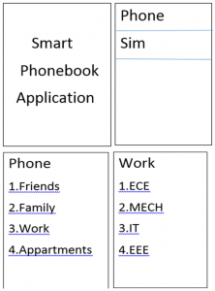

**Conclusion :**

A person having several contacts will enjoy this application, because the members in their list may confuse the user with the similar name though belonging to different categories. To overcome this problem, each person can be classified according to their respective categories.